FINAL YEAR PROJECT PROPSAL


Presented by:
Student name | Reg no
Ayesha Nazir | 22-SE-079
Hamza Moeen | 22-SE-025
Supervisor
Mr. Junaid Ali Khan

DEPARTMENT OF COMPUTER SCIENCE
BS SOFTWARE ENGINEERING PROGRAM
HITEC UNIVERSITY TAXILA

Project Title
AuralAid: Adaptive AI Hearing with Contextual Understanding
Project Advisor
Mr. Junaid Ali Khan
Particulars of the students:
S.No | Registration# | Name | CGPA | Signatures
1 | 22-SE-079 | Ayesha Nazir | 3.51
2 | 22-SE-025 | Hamza Moeen | 3.00

Advisor’s Consent
I Prof./Dr./Mr./Ms. ___________________ am willing to guide these students in all phases of above-mentioned project / thesis as advisor. I have carefully seen the Title and description of the project / thesis and believe that it is of an appropriate difficulty level for the number of students named above.
Note: Signature and Date
Advisor can’t be changed without prior permission of the fyp In-charge and the duration for completion of Research Project / Thesis is 10 months (approx.) from the date of Registration of Research Project/Thesis.

Advisor
Co-Advisor
I have carefully read the project proposal and feel that the proposed project is a useful one and of a sufficient difficulty level to justify a one-year work load of above-mentioned students.
Recommended Signatures and Date
Yes No

Table Of Content
Abstract 6
1. Introduction 7
1.1. Background Error! Bookmark not defined.
1.2. Problem Statement 8
1.3. Objective 8
1.4. Scope 10
2. Business Requirements 11
2.1 Business Opportunity Error! Bookmark not defined.
2.2 Business Objectives and Success Criteria Error! Bookmark not defined.
2.3 Customer or Market Needs: Error! Bookmark not defined.
3. Literature Review 11
3.1. Related Work 13
3.1.1. Research Papers 13
3.1.2. Web Applications 14
3.2. Research Gap 15
4. Proposed Solution/Methodology: 16
4.1. Project Major Features: 16
4.2. Project Approach 17
4.3. Project Design 18
4.3.1. Flowchart
4.3.2. Use Case: 20
4.3.3. Data Flow Diagram: 23
5. Technical Specification 24
5.1. Programming Languages: 24
5.2. Tools and Technologies: Error! Bookmark not defined.
5.3. Hardware and Resources: 25
5.4. Others: Error! Bookmark not defined.
6. Project Plan/Schedule 26
6.1. Timeline/Milestone: Error! Bookmark not defined.
6.2. Identified Risk and Management Error! Bookmark not defined.
6.3. Practical Implications: Error! Bookmark not defined.
7. Conclusion: 29
References: 29

Abstract
This project focuses on developing a Smart Hearing Aid System that aims to improve the daily communication and safety of people with hearing loss through intelligent and affordable technology. Hearing loss is a serious and rapidly increasing global problem that affects millions of individuals, making it difficult for them to interact and participate confidently in social or noisy environments. Traditional hearing aids only amplify sounds, which often leads to confusion in crowded or noisy places because they cannot filter unwanted background noise or recognize the emotional tone of speech. To overcome these limitations, our proposed smart hearing aid will use digital signal processing (DSP) techniques to reduce noise and enhance the clarity of speech. It will also provide real-time text captions of spoken words, allowing users to read what others are saying instantly. Moreover, it will include emotion detection, helping users understand whether the speaker is happy, sad, or angry, and noise alerts that warn the user through light or vibration when the surrounding sound level becomes unsafe. The prototype will be built using low-cost and open-source hardware like the ESP32-S3 microcontroller and MEMS microphone to ensure affordability and accessibility. Additionally, a mobile or web-based interface will be developed to display captions, emotional feedback, and safety alerts clearly and in real time.
The expected result is a fully functional and smart prototype that combines AI, IoT, and embedded systems to offer a complete assistive solution for hearing-impaired individuals. The system will not only improve communication and safety but also promote confidence, independence, and inclusion for users in both personal and social settings. From a research and technological perspective, this project contributes valuable knowledge to the fields of wearable computing, signal processing, and human-computer interaction. Its innovative and cost-effective design shows how advanced assistive technologies can be made accessible to everyone, reducing the gap between innovation and real-world usability.

Introduction
This document presents an overview of the Smart Hearing Aid System, a modern solution designed to assist individuals with hearing impairments using advanced technology. As hearing difficulties continue to rise globally, there is a strong need for intelligent, affordable, and efficient hearing-assistive devices. This introduction explains the background, motivation, problem statement, objectives, and scope of the project.
1.1 Background:
Hearing loss affects over 1.57 billion people worldwide, which is about 20% of the global population (The Lancet, 2019). Among children and adolescents, prevalence has increased from 3,537 to 3,711 per 100,000 between 1990 and 2021 (BioMed Central). Another study estimated that around 466 million people live with disabling hearing loss (WHO, 2018).
Traditional hearing aids, though effective, often lack smart functionalities such as real-time noise filtering, speech-to-text captioning, and emotion recognition. Furthermore, high costs and limited accessibility make them unaffordable for many.
Our project aims to bridge this gap by designing a low-cost, AI-enabled, and IoT-connected Smart Hearing Aid prototype that not only amplifies sound but also enhances communication and safety.
1.1.2 Motivation:
The motivation behind this project is to empower hearing-impaired individuals by combining embedded systems, AI, and IoT technologies into a single, wearable solution.
(a) Bridging the Gap
Most hearing aids only amplify sound; they don’t help users understand emotions or context. This system bridges that gap by integrating speech-to-text captioning and emotion detection, making communication more natural.
(b) Addressing Accessibility and Cost
Hearing solutions are often expensive. Our system uses open-source software and affordable hardware like the ESP32-S3 and MEMS microphones, ensuring that even low-income users can benefit.
(c) Real-Time Awareness
By including a noise-alert system, the prototype notifies users of hazardous environmental sounds — a vital safety feature missing in most traditional devices.
(d) Promoting Inclusive Technology
The project contributes to assistive technology research, encouraging innovation for inclusive and accessible smart devices.

1.2. Problem Statement

Hearing loss is one of the most common disabilities worldwide, affecting over 1.57 billion people about 45% of the global population and increase day by day. Despite this, access to affordable and intelligent hearing solutions remains limited.
Most existing hearing aids are either too expensive or lack smart functionalities such as real-time noise filtering, speech-to-text conversion, and emotion recognition. As a result, individuals with hearing impairments continue to face barriers in communication, social interaction, and environmental awareness.
There is a clear need for an intelligent, low-cost, and efficient hearing-assistive system that enhances communication and safety through smart technology integration.
1.2.1 Importance of the Problem:
Hearing ability is fundamental to human communication and overall quality of life. Without proper assistance, hearing-impaired individuals often experience social isolation, communication difficulties, and reduced access to education or employment opportunities.
Developing a smart, affordable hearing-aid system can drastically improve users’ ability to engage confidently in daily conversations, enhancing both independence and inclusion. Furthermore, this research supports ongoing advancements in assistive technologies and AI-based healthcare innovations.
1.2.2 Impact of Not Solving This Problem:
If the issue remains unaddressed, millions of individuals will continue to face communication barriers, safety risks, and limited social participation.
Without affordable, intelligent alternatives:
- Many hearing-impaired people will remain excluded from educational and professional opportunities.
- The cost of existing medical devices will continue to limit accessibility in developing regions.
- Society will lose potential contributions from talented individuals who are unable to fully engage due to hearing limitations.
- Addressing this challenge not only supports individuals but also promotes a more inclusive, connected, and empathetic society.

1.3. Objective

The main goal of the Smart Hearing Aid System is to design and develop an intelligent, low-cost, and efficient hearing-assistive prototype that improves the communication experience of hearing-impaired individuals using advanced embedded and AI technologies.
The specific objectives of the project are:
(a) To capture and process live audio efficiently/effective voice cancellation:
The system will use MEMS microphones to capture real-time audio, which will then be processed through an ESP32-S3 microcontroller to reduce background noise and enhance voice clarity.
(b)To implement real-time speech-to-text captioning:
The device will display live captions of spoken words on a connected mobile or web interface, enabling users to read conversations easily and naturally.
(c)To integrate emotion detection from speech:
By using AI models for emotion analysis, the system will recognize the emotional tone of the speaker, helping users better understand the context of communication.
(d)To develop a noise-level alert system:
The prototype will continuously monitor environmental noise and alert the user when sound levels exceed safe limits, thus improving safety in daily life.
(e)To ensure affordability and accessibility:
The system will be developed using open-source tools and low-cost hardware so that it can be adopted widely, especially in low-resource regions.
(f)To contribute to assistive technology research:
The project will serve as a base for future research and development in AI-powered auditory assistance and wearable IoT devices for healthcare applications.

1.4. Scope
The Smart Hearing Aid System focuses on creating a functional prototype that demonstrates real-time hearing assistance with integrated captioning, emotion recognition, and safety alerts. It aims to benefit hearing-impaired users, researchers, and developers working on assistive technologies.
1.4.1 What the System Will Cover

- Live Audio Capture and Filtering:
The system will capture environmental sounds using MEMS microphones and process them through DSP algorithms on the ESP32-S3 to remove background noise and enhance speech quality.
- Real-Time Caption Display:
It will convert spoken words into readable captions in real-time and display them on a connected mobile or web interface, ensuring improved speech comprehension.
- Emotion Detection:
By analyzing audio patterns, the system will identify speaker emotions such as happiness, sadness, or anger, offering better contextual awareness for users.
- Noise Alert Functionality:
The device will continuously monitor environmental sound levels and alert the user through visual or vibration cues when dangerous noise levels are detected.
- Low-Cost, Open-Source Development:
The system will be developed using cost-effective components and open-source software tools, promoting accessibility and innovation in assistive technology.
- Commercial Product Support:
Although developed as a prototype, the system will be designed with scalability in mind making future commercialization and product support feasible with minimal modifications.
- Cloud-Based Data Storage:
The project will integrate basic cloud connectivity for data synchronization and backup, allowing users to access processed results or system logs remotely.
- Full Mobile App Integration:
The system will feature a connected mobile application that supports live caption display, emotion visualization, and noise alerts. The app will be fully functional and compatible with Android devices for user-friendly interaction.

Business Requirements
The Smart Hearing Aid System aims to create an affordable, intelligent assistive device designed to enhance communication and safety for people with hearing impairments. Using AI, IoT, and embedded systems, the project focuses on real-time sound processing, caption generation, emotion detection, and hazardous noise alerts.
This project demonstrates how low-cost components like the ESP32-S3 and MEMS microphones can be used to build a functional prototype that supports hearing-impaired individuals while remaining suitable for research and educational development.

2.1 Business Opportunity:
The Smart Hearing Aid project opens multiple business and research opportunities in the growing field of assistive and wearable technology. The key opportunities include:
1. Affordable Assistive Technology for Developing Countries
Most commercial hearing aids are expensive and inaccessible to low-income individuals. This project demonstrates how open-source hardware and software can deliver similar features at a fraction of the cost creating opportunities for affordable healthcare products in developing regions.
2. Research and Educational Integration
The system can serve as a research and teaching tool for students and developers interested in embedded systems, IoT, and AI-driven health solutions. Universities and technical institutes can adopt the prototype for academic use, experimentation, and improvement.
3. Collaboration with Healthcare Providers
Hospitals, NGOs, and rehabilitation centers can use this solution to improve patient communication and monitoring. The system’s modular design allows it to be upgraded for clinical use or integrated into telehealth platforms.
4. Commercial Product Development
With further optimization, the project can evolve into a commercial product — offering advanced features such as mobile connectivity, adaptive sound filtering, and AI-based noise classification, making it competitive with existing hearing aid technologies.

2.2 Business Objectives and Success Criteria:
Objective ID | Business Objective | Success Criteria
BO-01 | Develop a Low-Cost Prototype Design a functional, affordable smart hearing aid using open-source tools and low-cost components. | The prototype cost should remain under 90K while maintaining reliable performance.
BO-02 | Enhance Real-Time Sound Clarity Implement DSP algorithms to filter background noise and improve sound quality. | Achieve at least 95% clarity in speech recognition during testing.
BO-03 | Provide Real-Time Captions and Emotion Detection Display live captions and identify speaker emotions on a connected device. | Ensure accurate captioning (90%) and emotion recognition (80%) accuracy.
BO-04 | Implement Noise Alert System Detect dangerous sound levels and notify the user through visual or vibration alerts. | Successfully detect hazardous sound levels above 85 dB with <2 sec response time.
BO-05 | Demonstrate Open-Source Applicability Use accessible hardware and software for reproducibility and educational use. | System documentation and code are freely available for research or student projects.
BO-06 | Prototype Demonstration and Usability Testing Validate the system with real users or simulated testing scenarios. | Gather positive feedback (80% satisfaction) from at least 60 test users.

2.3 Customer or Market Needs:
Hearing impairment affects over 1.5 billion people globally, including millions in developing countries where medical-grade hearing aids remain unaffordable. There is a growing need for cost-effective, intelligent, and accessible hearing solutions that go beyond simple sound amplification.
Key Market Needs:
- Affordability: Most advanced hearing aids cost hundreds of dollars. There is a need for an open-source, low-cost alternative suitable for developing regions.
- Real-Time Audio Processing: Users require clear and filtered sound for comfortable hearing in noisy environments.
- Visual Feedback (Captions): Real-time captions help hearing-impaired users understand speech more effectively in conversations or classrooms.
- Emotion Recognition: Enables better interpersonal communication by identifying speaker emotions.
- Safety Alerts: Provides warnings for high sound levels or environmental hazards through vibration or LED indicators.
- Lightweight and Portable Design: The solution must be comfortable, wearable, and energy-efficient for daily use.

Literature Review:
This project enhances communication and situational awareness for hearing-impaired users by providing real-time audio capture, speech-to-text captions, emotion detection, and noise alerts. Implemented on a low-cost embedded system with mobile app support, it offers an offline, user-friendly, and accessible solution.

Related Work:
Research in speech recognition and emotion detection has advanced, but most models require heavy computation or GPUs, making them unsuitable for embedded devices. Mobile apps like Google Live Transcribe and Sound Watch provide captions or sound alerts but rely on the internet and lack full integration. Commercial hearing aids offer advanced features but are expensive and closed-source. There is a need for a low-cost, offline, and flexible system combining speech recognition, emotion detection, and environmental awareness.

Research Papers:
Assistive devices for hearing-impaired users enhance communication and awareness by providing features like real-time captions, emotion recognition, and noise alerts. Most speech recognition and emotion detection models require heavy computation, while mobile apps rely on the internet and lack integration. Commercial hearing aids are expensive and closed-source, highlighting the need for a low-cost, offline, and flexible solution.
Table 1: Literature Review of Research Papers
Year | Title (Author) | Methodology | Limitation | Opportunity
2023 | Robust Speech Recognition via Large-Scale Weak Supervision [1] | Trains very large speech recognition models on huge audio datasets for good generalization | Requires very high computation; cannot run on small devices | Models can be simplified or compressed for small devices; use as teacher model for on-device learning
2021 | TensorFlow Lite Micro: Embedded ML Systems [2] | Framework for running ML models on microcontrollers; shows optimization steps | Limited model size and accuracy due to hardware limits | Allows lightweight speech/emotion models to run on ESP32 and similar MCUs
2020 | Real-time Speech Enhancement for Edge Devices [3] | Uses CNN+RNN for frame-by-frame speech enhancement on smartphones | Too heavy for microcontrollers | Can simplify and prune models for microcontroller deployment

Mobile Applications
This section reviews some existing mobile apps and systems designed to help people with hearing loss. Each has useful features, but also some limitations that our project aims to overcome.
Several mobile applications such as Google Live Transcribe, Otter.ai, and Sound Watch assist hearing-impaired users by providing speech-to-text captions, sound detection, and accessibility support. These apps improve daily communication and awareness but have limitations like internet dependency, lack of emotion detection, and no offline noise alerts. Most are also not suitable for wearable or embedded systems. Therefore, there is a clear need for a low-cost, intelligent, and all-in-one solution like our proposed Smart Hearing Aid System, which integrates captions, emotions, and noise alerts in one platform.
Table 2: Literature Review of Existing Systems
Platform Name | Strengths | Limitations | Platform Link
Google Live Transcribe | Gives accurate real-time captions in many languages; easy to use. | Needs internet all the time; no emotion or noise alert features. | Play Store
Otter.ai | Offers live transcription, meeting summaries, and cloud sync. | Works online only; not for small or wearable devices. | otter.ai
AVA Accessibility App | Helps deaf users with live group captions and sharing. | Internet required; no emotion or noise alerts. | ava.me
SoundWatch (UW) | Detects alarms or sirens; alerts user via smartwatch vibration. | Supports limited sounds; no captions or speech display. | soundwatchapp.com
Rogervoice | Shows real-time phone call captions in multiple languages. | Needs cloud servers; privacy concerns. | rogervoice.com
Google Hearing Aid (Pixel) | Smart hearing boost built into some Android devices. | Works only on limited phones; not customizable. | Support link
Live Caption (Android) | Captions videos and audios instantly, even offline. | Works only for media, not live conversations. | Support link
AI Hearing Aid (Oticon More™) | Uses AI for adaptive sound control; high accuracy. | Very expensive and closed-source. | oticon.com
TranscribeGlass | Projects captions from phone onto glasses in real-time. | Needs external phone app and internet; no emotion detection. | transcribeglass.com

Research Gap
Existing hearing systems and mobile apps provide features like speech transcription and sound alerts but still have many limitations, such as high cost, internet dependency, lack of emotion detection, and limited offline performance. Most are not open-source and cannot be customized for small or wearable devices. To overcome these issues, our project introduces a Smart Hearing Aid System that combines AI, DSP, and IoT to offer real-time captions, emotion recognition, and safety alerts in a low-cost and offline-capable design. This system fills the gap between affordability, functionality, and accessibility in modern hearing-assistive technology.
Table 3: Research Gap

Research Area | Current Work | Limitations | Our Solution | Expected Benefit
Live Audio Capture | Commercial hearing aids | Expensive, not open-source | Use low-cost ESP32-S3 with MEMS mic and DSP | Real-time, clear, and affordable sound capture
Real-Time Captions | Google Live Transcribe, Rogervoice | Needs internet, slow offline | Local speech-to-text with Android/web view | Fast, offline captions with low delay
Emotion Detection | AI research datasets (RAVDESS, Emo-DB) | Heavy processing needs | Lightweight AI model on ESP32-S3 | Helps users sense speaker’s emotion easily
Noise Alerts | SoundWatch, SoundAlert | Limited to few sounds | Monitors noise and alerts via LED/vibration | Improves user safety and awareness
Commercial Support | Research prototypes | Not scalable or market-ready | Modular and scalable design | Can turn into real, marketable product
Mobile App Integration | Research prototypes | Complicated and incomplete UI | Android app for captions, emotions, alerts | Easy and user-friendly experience
Education & Research | Commercial devices | Closed, not for learning | Open-source and well-documented system | Helps students and researchers experiment

Proposed Solution/Methodology:
To achieve the objectives of AuralAid, the project will adopt an AI-driven approach to assist individuals with hearing impairments. The solution focuses on real-time audio processing, emotion detection, noise filtering, and health monitoring, combined with mobile connectivity for better accessibility and user experience.

4.1. Project Major Features:

1. Capture Audio:
The smart hearing aid device continuously captures ambient sound in real-time. This feature ensures the user receives clear audio input while the system processes it for noise reduction and speech detection.
2. Filter Noise:
AuralAid uses AI-based noise filtering to remove background sounds, enhancing the clarity of conversations and reducing auditory strain.
3. Convert Speech to Text (STT)
The device converts speech into readable text on the mobile app, enabling users with hearing impairment to follow conversations effectively in real-time.
4. Detect Emotion
Using emotion detection algorithms, the system interprets the tone, pitch, and intensity of speech to identify emotions such as happiness, anger, or sadness. The mobile app displays the emotional context to help users understand the speaker better.
5. Noise Alert
The system provides real-time alerts if environmental noise exceeds safe hearing levels, protecting users from potential hearing damage.
6. Monitor Health
The wearable device tracks vital health parameters like heart rate, body temperature, and SpO₂ levels. These readings are sent to the mobile app for continuous monitoring.
7. Send Health Alerts
If any abnormal health metrics are detected, the system sends immediate notifications to the user and optionally to caregivers via the app.
8. App Connectivity
The device maintains Bluetooth/Wi-Fi connection with the mobile app, enabling seamless data synchronization, alerts, and real-time display of speech and health information.

4.2. Project Approach:

1. Hardware & Integration Methodology
This methodology focuses on embedded systems design and hardware-software integration.
Key Components & Roles:
- ESP32-S3 Edge Processor: Low-power DSP core for real-time noise reduction and sensor data aggregation.
- Raspberry Pi 4 Dev/AI Hub: AI prototyping and benchmarking, offline ASR testing, and training ML models for emotion detection and summarization.
- Audio & Bio-Metrics Sensors: Dual MEMS microphones, HR, SpO₂, and temperature sensors provide high-fidelity audio and physiological data.
- Output Devices: DAC, audio receiver, and haptic motor deliver low-latency audio and tactile alerts.
- Mobile App (Flutter + BLE): UI/UX, API management, and serves as the ASR host environment.
Methodology Type:
- Embedded Systems & Hardware-Software Integration
Purpose: Ensures sensor connectivity, real-time processing, and seamless mobile interaction.

2. Real-Time Processing & Algorithm Methodology
2.1 Edge DSP (ESP32-S3)
- Noise Reduction: Spectral Subtraction / FxLMS algorithm applied to audio frames.
- Ambient dB Alert: RMS calculation on non-speech channels for continuous monitoring.
Methodology Type: Digital Signal Processing (DSP)
Purpose: Real-time audio cleaning and environmental noise alerts.
2.2 Advanced AI Processing (Mobile / Cloud)
- Speech-to-Text (ASR): RNN/Transformer models (Whisper.cpp, Vosk, or Google Speech API).
- Emotion Detection (SER): Machine learning models (SVM/CNN) using vocal features (MFCC, pitch, energy) and optional bio-metrics.
- Smart Captioning: NLP keyword/entity extraction (spaCy/NLTK or fine-tuned T5-small model).
- Safe Route Finder: Geospatial routing via Google Maps API using real-time and historical noise data.
Methodology Type: AI/ML and NLP
Purpose: Enables emotion recognition, speech captioning, and smart route suggestions.

3. Testing & Validation Methodology:
This methodology focuses on system evaluation and quality assurance:
- Noise Reduction: Segmental SNR measured via hardware-in-the-loop simulation with standardized noise profiles.
- ASR Accuracy: Word Error Rate (WER) evaluated against noisy and denoised speech datasets.
- System Latency: End-to-end measurement of audio-to-caption latency via BLE/cloud connectivity.
Methodology Type: Hardware-in-the-loop Testing & Performance Validation
Purpose: Ensures accuracy, reliability, and real-time performance of the system.

Project Design

The design of the Smart Hearing Aid System focuses on creating a compact, efficient, and user-friendly prototype that integrates hardware and software components to assist hearing-impaired individuals. The system architecture is divided into multiple layers—hardware, processing, communication, and application—to ensure smooth data flow and real-time performance.
At the hardware level, MEMS microphones capture environmental audio, which is then processed by the ESP32-S3 microcontroller using Digital Signal Processing (DSP) algorithms for noise reduction and speech enhancement. The processed data is transmitted to the mobile or web interface, where live captions and emotion-based feedback are displayed for better understanding.
The software design includes modules for speech-to-text conversion, emotion detection, and noise alert notification. A dedicated mobile application provides an intuitive interface that allows users to view real-time captions, receive alerts for high sound levels, and monitor speaker emotions seamlessly.
The entire system emphasizes low-cost, open-source development to make it accessible for educational and research purposes, while maintaining flexibility for future commercial scalability. The overall design ensures reliability, real-time response, and ease of use, making it a valuable assistive technology for individuals with hearing impairments.

Block Diagram
The block diagram represents the Assistive Hearing and Emotion Detection System architecture, which is organized into the following layers:

- Hardware Layer:
This layer includes all physical components such as MEMS microphones, amplifiers, ESP32-S3 microcontroller, Raspberry Pi, and health sensors. It captures environmental and speech audio, amplifies signals, and transmits them to the processing unit for further analysis.

- Processing Layer:
The ESP32-S3 and Raspberry Pi work together in this layer to perform digital signal processing (DSP), noise filtering, emotion recognition, and speech-to-text conversion. It serves as the brain of the system, executing the algorithms required for accurate detection and interpretation of sounds.

- Software/Application Layer:
This layer manages real-time caption display, emotion visualization, and noise alert functionalities through a connected mobile or web interface. It ensures user-friendly interaction by allowing users to view live captions, receive alerts, and monitor processed data.

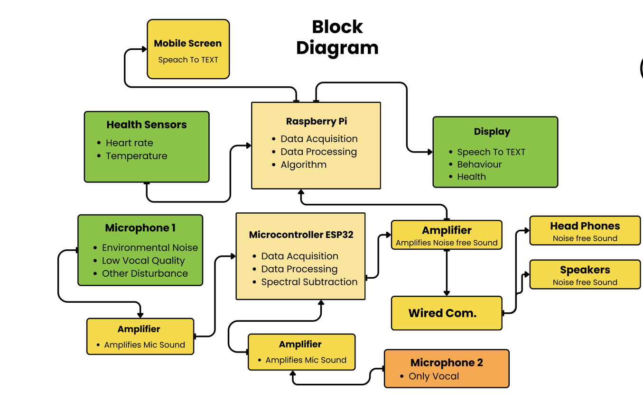

Figure 1: Block Diagram of Advance Hearing Aid System

Use Case:
Actors:
User: Represents the hearing-impaired individual using the Smart Hearing Aid System. The user interacts with both the wearable device and the connected mobile application to access live captions, emotion detection, and health alerts.
Admin / Healthcare Provider: Manages system configuration, monitors patient health data, and performs remote updates or diagnostics.
Mobile App: Acts as an external interface between the user and the wearable device. It receives real-time data such as live captions, emotion indicators, and health readings, and displays them in a user-friendly format. It can also send control commands or configuration settings to the device.
Use Cases:
- Capture Audio:
The wearable unit captures environmental sounds using MEMS microphones.
- Filter Noise:
The ESP32-S3 microcontroller applies DSP algorithms to remove background noise and improve speech clarity.
- Convert Speech to Text:
Real-time speech is converted into readable captions and transmitted to the connected mobile app for display.
- Detect Emotion:
The AI module analyzes tone, pitch, and frequency to detect emotions such as happiness, sadness, or stress. Results are displayed on the mobile application.
- Monitor Health:
Health sensors continuously measure vital signs like heart rate, temperature, and SpO₂.
- Send Health Alerts:
If abnormal readings are detected, alerts are generated and shown on the mobile app. Notifications may also be sent to the admin or healthcare provider.
- Noise Alert:
The system warns the user through vibration or on-screen alerts when noise levels become unsafe.
- App Connectivity:
Enables communication between the wearable unit and the mobile app using Bluetooth or Wi-Fi for real-time data exchange.

Representation:

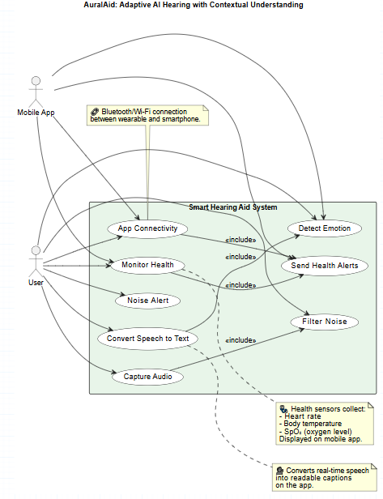

Figure 2: Use Case of Advance/smart hearing aid System

4.3.3. Data Flow Diagram:

Components:
Input Layer:
- MEMS Microphones: Capture environmental audio signals.
- Health Sensors: Collect body vitals like heart rate, temperature, and SpO₂.
- Processing Layer (ESP32-S3 + AI Module):
- Filters noise, enhances sound quality, and detects emotions from voice data.
- Processes health readings and checks for abnormal conditions.
- Sends processed data to the mobile application and storage system.
Storage Layer:
Stores sound data, captions, emotional feedback, and health records locally or on the cloud.
Output Layer:
- Mobile/Web App: Displays real-time captions, health readings, and alerts.
- Alerts/Feedback System: Provides vibration or visual alerts for noise and health warnings.
User Interaction:
The user views captions and health updates, while the admin monitors logs and system health remotely.
Representation:
The DFD represents how input from both the audio and health sensors flows through the processing module and reaches the output devices, ensuring continuous monitoring, feedback, and smart assistance.
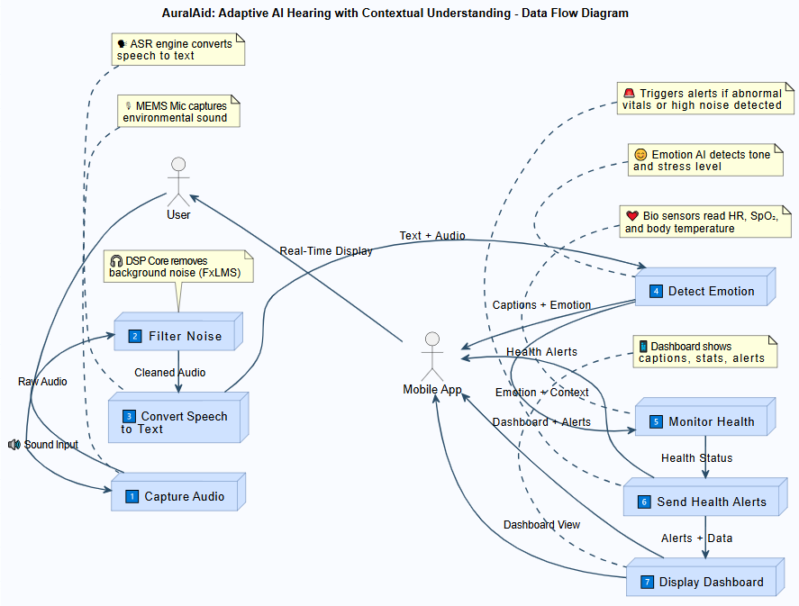

Figure 3: DFD of Advance hearing Aid System

Technical Specification:
This section highlights the tools, technologies, and system components used in developing the proposed AI-powered hearing aid system. It explains the software environment, unique features, and core hardware setup that together create an efficient, low-cost, and intelligent solution for hearing-impaired users.

5.1. Tool and technique:
To build a robust and interactive hearing enhancement system, a combination of embedded programming tools, AI frameworks, and cloud platforms is utilized. These technologies ensure smooth integration between hardware, mobile applications, and real-time processing modules.

Table 4: Tools and techniques

Category | Tool / Technology | Purpose / Description
Embedded Programming | Arduino IDE / ESP-IDF (C / C++) | Used for programming ESP32 boards, handling sensor data, digital signal processing (DSP), and BLE communication.
Signal Processing | FreeRTOS + ESP-DSP Library | Enables real-time multitasking and advanced noise reduction algorithms (FxLMS, NS).
Mobile App Development | Flutter SDK (Dart) | Develops a cross-platform mobile app for user interface, BLE connectivity, live captions, and emotion-based alerts.
AI-Machine Learning | TensorFlow Lite PyTorch | Runs speech recognition, summarization, and emotion detection models on Raspberry Pi or cloud.
Geolocation | Google Maps API | Supports Safe Route Finder feature to guide users through quieter, safer areas.
Communication | Bluetooth Low Energy (BLE) | Enables real-time data exchange between the hearing device and mobile app.
Version Control | Git / GitHub | Manages source code and collaboration.

Unique and Innovative Features:
The system integrates multiple intelligent features that go beyond traditional hearing aids. It not only enhances sound clarity but also detects emotions, monitors health, provides safe navigation, and ensures continuous cloud connectivity for an adaptive user experience.
1. Real-Time Noise Reduction/Effective Noise cancellation:
Powered by ESP32-S3 and ESP-DSP, the system isolates human speech from background noise using adaptive filters and noise suppression algorithms ensuring clear audio in noisy environments.
2. Emotion & Health Monitoring:
Integrated MAX30101 and TMP117 sensors measure heart rate, SpO₂, and temperature, while AI analyzes vocal tone and bio-signals to detect emotional states (happy, sad, stressed).
3. AI-Powered Speech Summarization:
The system uses transformer-based models (e.g., TFLite) to generate short summaries of long conversations helping users recall key details.
4. Safe Route Finder:
Combines GPS + Google Maps API to guide users through low-noise routes, improving safety and comfort for hearing-impaired individuals.
5. Intelligent Alerts & Haptic Feedback:
Built-in coin vibration motors deliver subtle vibration alerts for sudden loud noises or warnings maintaining awareness without disturbing the user.

5.4. System Architecture Layers and Components:
The proposed system architecture is organized into four main layers: the Hardware Layer, Processing Layer, Software/Application Layer, and Cloud Layer. Together, these layers form a seamless framework that enables real-time hearing assistance, health monitoring, and intelligent data management.
Table 5: system architecture layers with component

Layer | Main Components | Key Functions / Description
Hardware Layer | MEMS Microphones, Amplifiers, ESP32-S3, Raspberry Pi, MAX30101 & TMP117 Sensors | Captures environmental and speech audio, amplifies signals, and collects health data for processing.
Processing Layer | ESP32-S3 Microcontroller, Raspberry Pi 4 , DSP Libraries (ESP-DSP, FreeRTOS) | Performs noise reduction, emotion recognition, and speech-to-text processing in real time.
Software / Application Layer | Flutter Mobile App, BLE Module, UI Components, AI Models (TFLite) | Displays live captions, emotion states, and noise alerts; ensures user-friendly interaction via mobile interface.

Project Plan/Schedule:
The project plan for the Advanced Hearing Aid follows a structured, milestone-driven approach to ensure smooth development, integration, and testing of both hardware and software components. The plan defines key phases, roles, and timelines for efficient execution of embedded system design, AI model integration, and user testing.

6.1 Timeline / Milestones:
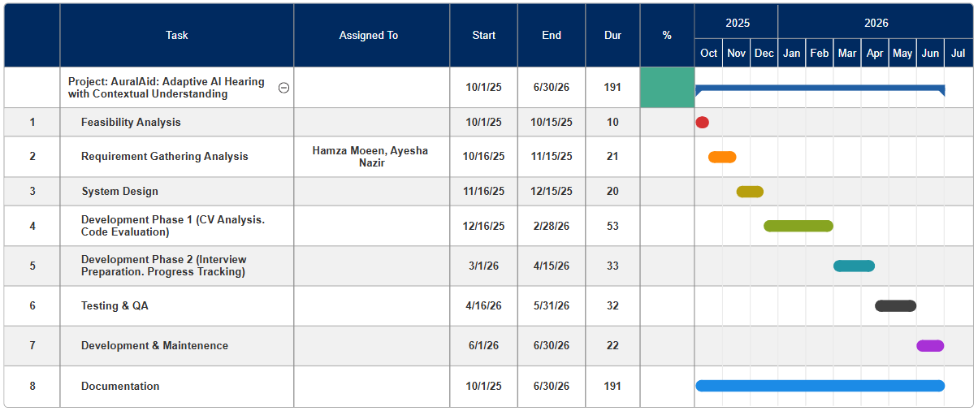
Figure 4: Gantt Chart of Adaptive AI Hearing with Contextual Understanding

6.2 Identified Risks and Management:
Every project faces certain risks that can affect its success. In this system, risks are related to hardware performance, algorithm stability, communication delay, and data security. Identifying these risks early helps in planning effective solutions to minimize their impact. The goal is to ensure the system works smoothly, remains secure, and delivers reliable results under real-world conditions.
Table 6: Identified Risks

Risk ID | Risk Description | Category | Impact | Likelihood | MitigationManagement Strategy
R1 | Hardware Compatibility Issues: Some sensors or boards may not work properly together. | Technical | High | Medium | Test each component early, use trusted libraries, and keep backup hardware available.
R2 | Speech Recognition Accuracy: Background noise or limited data may reduce the accuracy of captions. | Functional | High | Medium | Use pre-trained ASR models like Whisper or Vosk and apply noise reduction filters.
R3 | Emotion Detection Reliability: Emotional tone can vary by user or accent, reducing recognition accuracy. | Algorithmic | Medium | Medium | Train lightweight AI models on diverse datasets and add a calibration phase for each user.
R4 | Power Consumption: Running sensors, AI, and Bluetooth together may drain the battery quickly. | Hardware | Medium | High | Use power-saving modes, efficient firmware logic, and rechargeable Li-Po batteries.
R5 | User Privacy and Data Security: Sensitive voice and health data may be exposed during transfer or storage. | Security | High | Medium | Encrypt all data, store minimal personal info, and ensure secure cloud authentication.
R6 | User Acceptance and Usability: Users might find the prototype difficult to wear or interact with. | Human Factors | High | Medium | Gather feedback through user testing and improve design and app interface for comfort and simplicity.

6.3 Practical Implications:
The Advanced Hearing Aid System holds strong practical potential in healthcare, accessibility, and assistive technology domains:
  - Healthcare and Accessibility:
Enhances the lives of hearing-impaired individuals by providing real-time speech enhancement, emotion tagging, and ambient noise alerts.
Can be integrated into smart healthcare ecosystems for continuous monitoring of user vitals (pulse, temperature).
  - Elderly Support and Safety:
Assists elderly users by providing haptic alerts in high-noise or hazardous environments.
Emotion and stress detection features enable timely medical responses.
  - Smart Wearables Market:
Expands opportunities for advanced AI-driven wearable devices combining audio processing and biometric feedback.
Offers a platform for integrating advanced features like speech summarization and geolocation-based noise safety alerts.
  - Research and Development:
Provides a foundation for future work in embedded AI, adaptive hearing technologies, and personalized auditory augmentation.
Encourages innovation in edge-based AI systems capable of functioning without constant internet dependence.

7. Conclusion:
In conclusion, the development of the Advanced AI-Powered Hearing Aid System represents a significant advancement in assistive audio technology, combining the power of artificial intelligence (AI), signal processing, and embedded systems to enhance auditory perception and environmental awareness for individuals with hearing impairment. This project successfully integrates speech enhancement, emotion recognition, and sound event detection into a compact, wearable platform that adapts intelligently to the user’s surroundings.
Through the use of MEMS microphones, MAX30101 biometric sensors, and low-power microcontrollers, the device ensures real-time processing of environmental sounds while maintaining portability and energy efficiency. The inclusion of TinyML frameworks (TensorFlow Lite Micro) and optimized AI models enables efficient on-device processing without dependency on cloud computation — ensuring both low latency and user data privacy.
The research foundation built upon existing literature — including state-of-the-art models such as Whisper (Radford et al., 2023) and TinyML implementations (David et al., 2021) — demonstrates how large-scale AI models can be distilled and adapted for embedded systems. The integration of speech emotion recognition (Lieskovská, 2021), environmental awareness (Xia et al., 2021), and TinyML-based classification (Maayah et al., 2023) further enhances the system’s intelligence and usability.
From a practical perspective, this smart hearing aid not only amplifies and clarifies speech but also provides contextual awareness — such as detecting alarms, approaching vehicles, or emotional tone in speech — to improve both safety and communication. The device’s real-time vibration feedback, adaptive filtering, and AI-driven audio enhancement make it highly beneficial for elderly users, hearing-impaired individuals, and wearable technology research.
Despite challenges such as hardware limitations, model optimization, and battery efficiency, the project demonstrates strong feasibility through modular design, TinyML optimization, and future integration with cloud-based learning systems. The system can be further improved by incorporating edge-cloud hybrid models, multi-sensor fusion, and personalized AI tuning based on individual hearing profiles.
Overall, this project contributes to the growing field of intelligent assistive devices by presenting a scalable, AI-driven, and user-friendly solution that bridges the gap between medical-grade hearing aids and modern wearable AI systems. The Advanced Hearing Aid System stands as a step toward inclusive technology that empowers individuals to reconnect with their environment through smart, adaptive, and accessible innovation.

8.References:
[1] A. Radford, J. W. Kim, T. Xu, G. Brockman, C. McLeavey, and I. Sutskever, “Robust Speech Recognition via Large-Scale Weak Supervision,” arXiv preprint arXiv:2212.04356, 2023.
[2]David, R., Duke, J., Jain, A., Reddi, V. J., Jeffries, N., Li, J., Nappier, I., Natraj, M., Wang, T., Warden, P., Rhodes, R., Caulfield, B., & Mozafari, B. (2021). "TensorFlow Lite Micro: Embedded Machine Learning on TinyML Systems." Proceedings of Machine Learning and Systems (MLSys 2021), 3, 800–811.
[3] S. Shankar, G. Pandey, and M. Reddy, “Real-Time Single-Channel Deep Neural Network-Based Speech Enhancement for Edge Implementation,” IEEE Access, vol. 8, pp. 158498–158509, 2020.

